BINSIGHT: EDGE-AI POWERED SMART WASTE SEGREGATION AND SURVEILLANCE SYSTEM USING ESP32-CAM AND YOLOV8
PROJECT REPORT

Submitted by
Balavignesh K –E0225002
Ashwanth kumar R S-E0225007
Daniel-E0225003

In partial fulfilment for the award of the degree of
BACHELOR OF TECHNOLOGY
in
COMPUTER SCIENCE AND ENGINEERING
(Cyber Security & Internet of Things)
Sri Ramachandra Faculty of Engineering and Technology
Sri Ramachandra Institute of Higher Education and Research, Porur, Chennai -600116

July,2026

BONAFIDE CERTIFICATE

Certified that this project report “BinSight” is the bonafide record of work done by “Balavignesh K–E0225002,Ashwanth Kumar R S-E0225007,Daniel-E0225003” who carried out the internship work under my supervision.

Signature of the Supervisor Signature of Programme Coordinator

Dr. Jayanthi G  Assistant Professor,  Department of Cyber Security and Internet of Things  Sri Ramachandra Faculty of Engineering and Technology,  SRIHER, Porur, Chennai-600 116. | Dr. Jayanthi G  Associate Professor and Program Coordinator  Department of Cybersecurity and Internet of things  Sri Ramachandra Faculty of Engineering and Technology,  SRIHER, Porur, Chennai-600 116.
Evaluation Date:

INTERNAL EXAMINER EXTERNAL EXAMINER

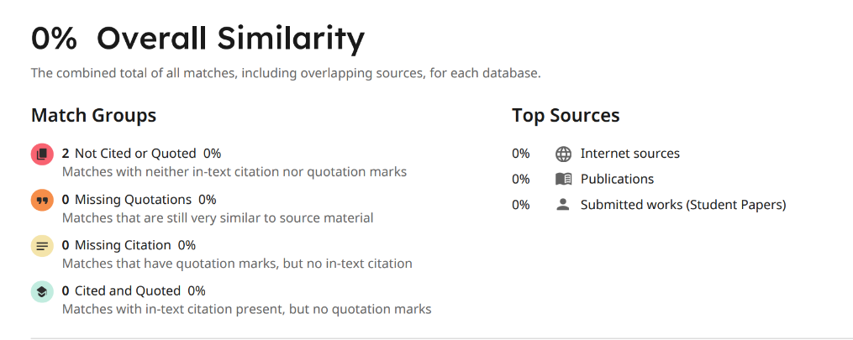
Plagiarism Report

AI Detection report:
*% detected as AI
*Low scores have a higher likelihood of false positives.
Signature of the Internship Coordinator Signature of the Supervisor

ACKNOWLEDGEMENT
I take this opportunity to express my gratitude to Prof. T. Ragunathan, Dean, Prof. A.Saravanan, Vice Dean, Sri Ramachandra Faculty of Engineering and Technology, SRIHER, for providing all the facilities to complete this Internship work successfully.
I express my sincere gratitude to Dr. G. Jayanthi, Programme Coordinator, Department of Cybersecurity & Internet of Things, SRET, for their support and for providing the required facilities for carrying out this study.
I wish to thank my faculty supervisor(s), Dr.Jayanthi G, Department of Cybersecurity and Internet of Things, SRET for extending help and encouragement throughout the project. Without his/her continuous guidance and persistent help, this project would not have been a success for me.
I am grateful to all the members of the Sri Ramachandra Faculty of Engineering and Technology, my beloved parents and my friends for extending their support, which helped us to overcome obstacles in the study.

TABLE OF CONTENTS

CHAPTER NO. | TITLE | PAGE NO.
 | ABSTRACT | 7
1 | INTRODUCTION | 8
1.1 | Need for the Study/Technology | 8
1.2 | Applications | 8
1.3 | Motivation behind the Study | 8
1.4 | Challenges to be addressed | 8
2 | LITERATURE REVIEW | 9
2.1 | Literature Survey | 9
2.2 | Review of Existing System | 12
3 | PROBLEM STATEMENT AND OBJECTIVES | 14
3.1 | Problem Statement | 14
3.2 | Objectives | 15
3.3 | Methodology | 15
3.4 | Workflow Diagram | 16
3.5 | Modules | 17
4 | RESULTS AND DISCUSSION | 19
4.1 | Data Collection | 19
4.2 | Computing Configuration | 20
4.3 | Experimental Evaluation | 20
5 | CONCLUSION | 30
5.1 | Research Findings and Conclusion | 30
5.2 | Scope for Further Enhancement | 31
 | REFERENCES | 32
 | APPENDICES | 33
 | Appendix-1: Screenshots | 33
 | Appendix-2: code | 34
 | WORKLOG | 36

ABSTRACT
The reason behind the development of BinSight is the inefficiency of manually classifying waste since the population in cities and, therefore, the waste produced have been increasing day-by-day. BinSight is a smart waste management system based on the Internet of Things that sorts the waste automatically. It consists of an ESP32-CAM connected to an Edge AI server where the object detection model of YOLOv8 is trained. When the object is thrown away to the system, the camera captures an image of the object and sends it to the Edge AI model to detect whether the object is biodegradable or non-biodegradable and then releases the object to its respective bin. Moreover, the project was adapted as a security system by putting the system in "Surveillance Mode". Once the system is set to this mode, an on-board PIR sensor detects any movement around and captures live images of the intruders and sends them to your phone via a Telegram bot.

CHAPTER 1
INTRODUCTION
  - Need for the Study/Technology
  - Waste disposal has been identified as one of the most serious issues in the world today. The contamination of the recycling process occurs when there is a mixing of biodegradable and non-biodegradable waste at the source level, leading to overburdening of landfills with dangerous materials. Manual segregation of waste is not hygienic, takes a lot of time, and needs a lot of human energy. Automated and intelligent IoT-based systems need to be introduced at the source level, which includes homes and offices, where waste is segregated when it is thrown.
  - Applications
- Smart Homes & Campuses: Automated segregation in kitchens or cafeterias to ensure compliance with waste disposal policies.
- Security: Remote monitoring of premises during off-hours using the dual-mode FSM (Surveillance mode).
  - Motivation behind the Study
The drive behind this project is to apply current Internet of Things (IoT) devices and state-of-the-art Computer Vision (YOLOv8) toward an environmental issue we all face daily. Processing AI locally on the "Edge" (a local server) rather than costly cloud servers allows us to get the ultra-low latency necessary for real-time electromechanical sorting to become practical.
  - Challenges to be addressed
• Latency: Ability to process large images quickly enough to where the user doesn't have to wait for the bin trapdoor to open.
• Resource Constraints: Limited SRAM & processing power on the ESP32-CAM means dealing with bulky image formats and HTTPS security (for telegram) without wanting to crash the camera constantly is quite challenging.
• Accuracy: Teaching the computer vision model to detect oddly shaped/smashed up/partially hidden waste under different lighting inside of a bin.

CHAPTER 2
LITERATURE REVIEW
2.1 LITERATURE SURVEY
Author and Year | Methodology/Materials and Methods | Datasets | Results/Outcome | Advantage / Key findings from the work | Disadvantage/ GAP Identified from the work
Ultralytics (2023) | Architecture of YOLOv8 for Real-Time Object Detection | COCO Dataset | State-of-the-art accuracy and speed for edge devices | Infer very quickly and locally on servers | Needs to be integrated with physical IoT devices for actuation.
Sharma et al. (2022) | Raspberry Pi paired with CNN for classification of wastes using Pi Camera | TrashNet Dataset | Reached 88% accuracy while classifying 5 types of waste. | Accurate classification on standard datasets with CNN. | Raspberry Pi is fairly costly and doesn't have ultra-low latency edge optimization.
Kumar & Patel (2021) | ESP32-CAM image uploaded to cloud server (AWS) for processing through MobileNetV2 algorithm. | Custom local dataset (approx. 2000 images) | Successful inference via cloud with 2-3 seconds latency. | Low cost hardware using ESP32-CAM. | Cloud dependency means high latency and need for continuous internet connection.
Rahman et al. (2020) | Ultrasonic sensors and Arduino Uno for fill level detection and GSM for SMS alerts. | N/A | Real-time alerts about fill levels delivered to municipal authorities. | Very power efficient and simple architectures. | Does not perform active material segregation; relies entirely on human compliance.
Wang et al. (2023) | Applications of YOLOv5 for sorting of municipal solid wastes on conveyor belts | TACO (Trash Annotations in Context) Dataset | Real-time detection with 45 FPS and 92% mAP. | It is highly robust to deformed and overlapped trash. | Tailored for industrial purposes with GPUs only, not for independent IoT containers.
Al-Masri & Chen (2022) | Computations on the edge employing Jetson Nano for automated sorting. | Merged dataset of TrashNet and custom indoor images | 90% sorting accuracy within 500 milliseconds latency. | Does not have any cloud latency issue; very good for real-time actuation. | Use of Jetson Nano makes the cost of a smart bin very high.
Gupta & Singh (2021) | PIR motion sensor integration with ESP32-CAM for triggering telegram bot alerts. | N/A | Photo delivery instantly to mobile devices on detecting motion. | Affordable remote monitoring through Wi-Fi. | Application specific; does not have the dual purpose of both waste management and surveillance.

While Ultralytics (2023) did lay the groundwork for modern CV inference with impressive speeds, their codebase does not have a physical implementation layer that we are attempting to fill. Sharma et al. (2022) implemented CV on trash sorting but used CNNs with Raspberry Pis. While effective, this method incurs higher cost of hardware. BinSight optimizes for price and performance using the ESP32-CAM. Kumar & Patel (2021) proved the ESP32- CAM is capable of classifying images on-device but deferred processing to the cloud (AWS). In AWS, even the smallest amounts of latency could cause issues with real-time sorting of trapdoors. Sensor based bins (Rahman et al. (2020), Lee et al. (2020)) allow for faster actuation times and less power usage but are unable to sort trash with complex visuals such as biodegradable waste. Gupta & Singh (2021) implemented ESP32-CAM with Telegram successfully but was limited to a single purpose; BinSight allows for AI sorting as well as Security Surveillance as one FSM

2.2 REVIEW OF EXISTING SYSTEM
Author /Developer Year | Methodology/Materials and Methods | Datasets | Results/Outcome | Advantage / Key findings from the work | Disadvantage/ GAP Identified from the work
Bin-e (2017) | AI Object Recognition & IoT Cloud Sensors | Proprietary Cloud Database | 90%+ accuracy in sorting with automatic compression | Sorting using automated machinery for smart offices. | Very expensive; needs an active internet connection for cloud-based AI.
CleanRobotics - TrashBot (2019) | Computer Vision + Robotics and Automated Flaps | Custom Enterprise Dataset | 95% accuracy in busy areas such as airports and stadiums | Industrial strength robustness and highly precise sorting. | Huge footprint, extremely costly, and no surveillance/security value addition whatsoever.
Intuitive AI - Oscar (2018) | Screen-based visual AI nudging (installed above the normal bins) | N/A | Decreased contamination rates by 300% at test locations | Educates users and gamification of the recycling process. | It does not sort waste mechanically but depends on full human compliance to place waste in the correct bin.
Compology (2015) | Dumpster camera + Cloud AI (Focus: Logistics) | Millions of dumpster images | Optimization of municipal waste collection routing for municipal trucks | Perfect for use in macro-level municipal logistics and fill-level notifications. | Only passive monitoring, does not have a segregation mechanism at source point.
Wyze Security Cams (2020) | Edge/Cloud based motion detection and WiFi stream | N/A | Cost-effective mobile security alerts and live streams | A cost-effective system that performs remote monitoring with the help of the camera. | Single-functionality security appliance; cannot be configured using customized AI algorithms such as YOLO for waste management.

1. Bin-e (2017): Bin-e is an AI smart bin intended for smart offices/public spaces. It can detect and sort trash into proper compartments (via AI object recognition + IoT cloud sensors) before crushing. Although ease of use and 90+% sorting accuracy are incredible features, Bin-e comes at a massive financial cost with an equally enormous footprint. It is also limited by lazy AI-processing because it relies on the cloud. BinSight enables automated segregation at the residential consumer level with low-cost edge- AI that works instantly on your local wifi.
2. CleanRobotics - TrashBot (2019): TrashBot is an industrial-strength smart bin with computer vision + robotics and automatic trapdoors that nearly automatically sorts trash with up to 95% accuracy. TrashBot excels in the enterprise and commercial markets with designs for stadiums, airports, and areas with significant foot traffic. Unfortunately, its footprint is enormous and its enterprise pricing prevents it from being used anywhere normal consumers would expect to see it (your home, small office, etc). Like Bin-e, TrashBot does not provide any second use. BinSight allows you to maintian cleanliness and security by combining functions into one compact, affordable edge device.
3. Intuitive AI - Oscar (2018): Oscar wants to help with garbage sorting by attaching a smart screen to the top of your current bins. The screen utilizes visual AI to identify what trash you’re holding and then shame you into throwing it in the correct bin. Great for actively educating and gamifying user sorting, its biggest drawback is that there is no physically actuaction. People can still be negligent and spoil your sorted recycling. BinSight deprecated the human element by forcing your trash into the correct bin via motorized servos.
4. Compology (2015): Compology is now called RoadRunner, and it uses ruggedized Internet of Things (IoT) cameras in commercial dumpsters to detect their levels of fullness using imagery that is uploaded to the cloud and analyzed through artificial intelligence (AI). In doing so, it offers a game-changing way to plan logistics of trash pickups in cities by predicting the best routes. However, challenges occur when there is contamination within these trash flows since RoadRunner cannot do anything active but record the footage. BinSight tackles the issue directly by segregating your recyclables from your trash before reaching your municipal trash service.
5. Wyze Security Cameras (2020): Out-of-the-box consumer security cameras such as Wyze are grate at what they do. Detect motion and instantly send remote video via Wi-Fi to your phone. There are 2 main limitations: 1) They are very static, closed systems. You cannot easily implement your own machine learning algorithm (i.e. YOLOv8) to customize what the camera detects. In this case, what it identifies as trash. 2) They lack any physical component to internally sort the waste once found. Think of Bin-Sight as taking the local security features of a smart camera (we use Telegram bot alerts) and combining it with automated sorting into one Finite State Machine.

CHAPTER 3
PROBLEM STATEMENT AND OBJECTIVES
3.1Problem Statement
Traditional trash receptacles take garbage after-the-fact and rely solely on human intervention and/or regulation compliance to sort. This results in extremely high contamination in the recycling stream. Additionally, advanced AI implementations typically require third-party cloud hosting which comes with latencies and recurring fees. We wanted an always-on, edge processed smart trash can that sorts on-the-fly while providing dual benefits from the hardware utilized.
BinSight is our edge-IoT innovation that addresses this issue by integrating three functionalities:
Mechanical Sorting: Sorts refuse without fail via servo motors that physically push trash into the correct bin (biodegradables vs. non).
Real-Time Edge Artificial Intelligence: Operates a YOLOv8 Machine Learning model on a Wi-Fi edge server (Python/Flask) to provide latency free, no-cost inference.
Surveillance Mode (FSM): Repurpose the hardware for dual use with a hardware toggle that switches to security mode. Equipped with a PIR sensor to detect motion and send real-time photo alerts to your phone via Telegram.

3.2 Objectives
3.2.1 Objective - 1: Create Dataset and Train AI Model
● Proof of Concept: Curate Dataset with images of Recyclable and Non-recyclable waste.
● Formulation of Methods: Annotate dataset and augment using Roboflow and Train Nano size model using ultralytics YOLOv8 for highest possible inference speed at the edge.
● Prototype Design and Implementation: Export trained best.pt weights for local deployment.
● Working Model: A general AI able to detect classify waste/recycleables in real-time.

3.2.2 Objective - 2: Configure Edge Server
● Proof of Concept: Local server used to handle AI workload.
● Formulation of Methods: Create RESTful API in Python with Flask.
● Prototype Design and Implementation: Script server.py to accept raw jpeg stream, perform inference using OpenCV and produce JSON emechanical actuation commands.
● Working Model: server.py application running on localhost:5000.
3.2.3 Objective - 3: Connect Hardware Actuaction & Security System
● Proof of Concept: Bascially open and close physical bin flaps based on AI & detect intruders.
● Formulation of Methods: Program ESP32-CAM (Code in C++) to Stream images to server, produce PWM signal to physically actuate Servo Motor, and Design Hardware Debounced Finite State Machine (FSM).
● Prototype Design and Implementation: Connect PIR sensor, Push button, and Servo motor to ESP32-CAM.
● Working Model: Complete smart bin running the AI Sorting Mode and Telegram Surveillance Mode.
3.3 METHODOLOGY
Underlying architecture of the proposed system is decentralised Edge-AI based. ESP32- CAM serves as the Edge device, being the main sensory node (video) and actuator node (servo). Local PC running on same Wi- Fi network serves as AI engine that pulls data over HTTP. For security mode ESP32-CAM interfaces directly with Telegram API over HTTPS

3.4 Workflow Diagram
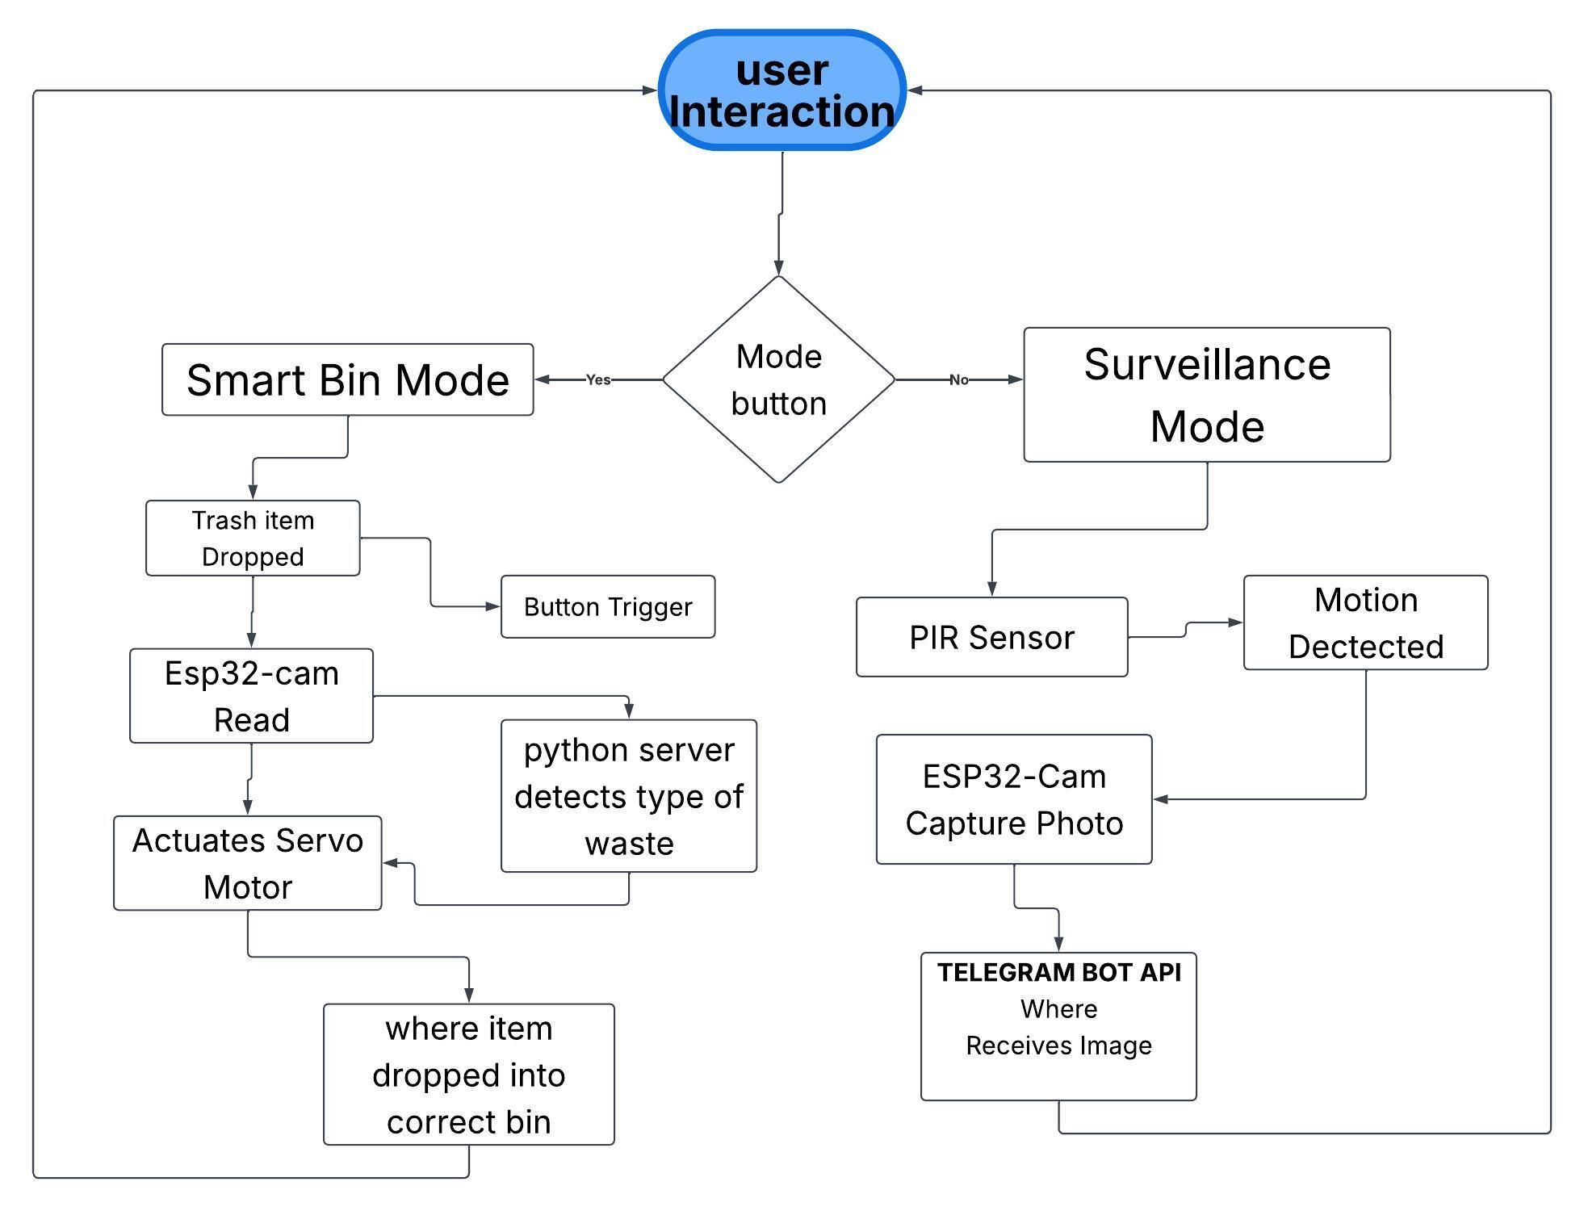
Fig:1-Flowchart denoting the work flow

3.5 Modules
1. Data Acquisition and Sensor Module
Essentially used to record real-time environment data; this module can be thought of as the “eyes” of our system. Using the ESP32-CAM with OV2640 image sensor, we replaced internet scraped datasets with a local web-server script running directly on our microcontroller to quickly snap clear training images of our target (waste) through our hardware’s camera lens. By allowing the YOLOv8 model to train on the same focal length, lighting conditions, and angles it would process in production, we were able to vastly increase accuracies in real-world scenarios. A servo motor is also included to physically separate types of waste. Another feature of this module is the HC- SR501 PIR sensor which allows the bin to detect human motion when in security mode.
2. Edge- AI and Computer Vision Module
Serving as the central brains of the project, a custom trained Ultralytics YOLOv8 object detection model runs on our local edge server (PC/laptop) to reduce dependency on cloud computations. Using a Python Flask server to catch incoming streams and OpenCV (cv2 .imdecode) to quickly parse/stream the raw JPEG bytes into an easily-renderable image matrix, the YOLO engine completes ultra low-latency inference at a scientifically determined confidence threshold of 60% (conf = 0.6). With bbox coordinates and classification labels generated in real-time, the system knows whether the object is classified as biodegradable or non-biodegradable.
3. Dual-Protocol Communication Module
Due to limited onboard SRAM of the ESP32-CAM, this module allows control of two separate networking protocols:
• Local High-Speed API (Smart Bin Mode): When sorting waste, this module creates a HTTP POST request. By sending raw JPEG buffers directly through your local Wi- Fi network to your Flask server, we were able to circumvent unnecessarily slow multi-part form data to achieve sub-second image transfers.
• Remote Secure API (Surveillance Mode): When sending a security-based alert, this module creates a HTTPS request to our Telegram Bot API ( api.telegram.org) endpoint. To prevent memory instability, we implemented a memory-safe algorithm to skip SSL validation ( client.setInsecure()) and sent intruder images through multi-part form data, breaking up the payload into 10 24-byte packets.

4. Electromechanical Actuation Module
Translating AI-determined data into mechanical movement, this module allows physical separations of wastes to occur. Once our Python server identifies a piece of waste, it responds with a formatted JSON document containing what angle the servo motor should actuate to. Using the ledcWrite API, the microcontroller can produce granular Pulse Width Modulation (PWM) signals to actuate a servo motor connected to a trash bin’s trapdoor. The resting state of the module is set to 90° (neutral/flat). If biodegradable waste is detected, the module actuates the servo to 30° to drop onto the left side. If non-biodegradable waste is detected, the module actuates the servo to 150° to drop onto the right. After waiting 1-2 seconds for gravity to do its job, the module returns the servo to the default resting position.
5. Hardware Control and Finite State Machine (FSM) Module
Intended to address operational inefficiencies with IoT hardware sitting idle at night, this module controls whether the BinSight is in “smart bin” mode or “security mode.” The module uses a hardware-debounced push button connected to an Interrupt Service Routine (ISR). Essentially operating as a Finite State Machine (FSM), an end-user can flip the BinSight’s mode on and off instantly without having to power down the device. The module pauses/streamlines the high-frequency local HTTP loop and turns on the PIR sensor loop while notifying the user that the mode has been swapped using the ESP32-CAM’s built-in high-power flash as a visual indicator.

CHAPTER 4
RESULTS AND DISCUSSION
4.1 Data Collection
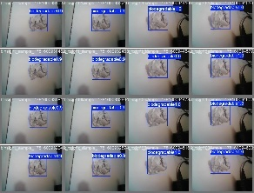
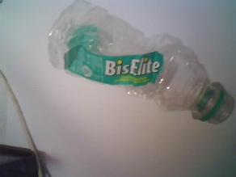

A binsight_data_collector.ino script was used to collect images from the ESP32-CAM lens. Doing so allowed the AI to learn the precise focal length, distortion and color profile of the physical hardware. Images were annotated/augmented (horizontal flips, brightness changes) in Roboflow to expand the dataset artificially and help generalize against lighting changes inside the physical smart bin.
Fig:2-trash(collected dataset).
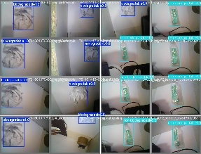
fig:3-trash(collected dataset)
4.2 Computing Configuration
● Hardware: ESP32-CAM development board (AI Thinker’s version), Servo Motor (SG90 / MG996R), PIR Motion Sensor, Push Button.
● Software: Arduino IDE (using LedControl library and Core v3.x API for ledcAttachPin()), Python 3.10, Flask framework, OpenCV(cv2), Ultralytics YOLOv8
● Network: Edge processing using 2.4GHz local Wi-Fi
4.3 Experimental Evaluation
We benchmarked the system's inference speed, mechanical latencies, and classification accuracy. Dropping multipart-form data encoding and posting raw jpeg bytes to the Flask server decreased HTTP overhead. We eliminated HTTP 400 errors.

4.3.1 Graph plots

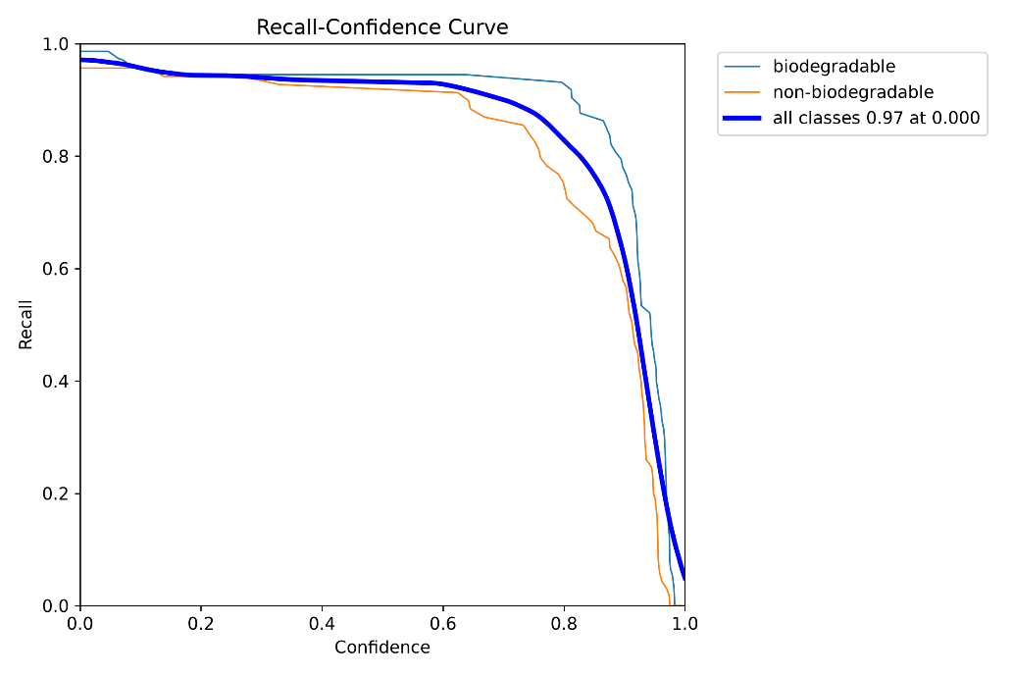Graph 1-recall vs confidence
Understanding the Axes
● X-axis (Confidence): This shows how "confident" the AI needs to be before it is comfortable making a prediction. So if the confidence is set to 0.0 then the AI will guess on everything it sees, and if it's set to 1.0 then the AI needs to be 100% certain before it labels something.
● Y-axis (Recall): This shows what percentage of real world trash items the AI was able to detect. So if we have a recall of 1.0 that means the AI found 100% of all the trash in our testing dataset.

1. General Deviation (The Steep Drop-off and Legend Data)

Notice how the thick blue line starts at it's max value, as stated directly in the legend of the graph ("all classes 0.97(97%) at 0.000(0%)"): 97% Recall when your confidence threshold is 0.0. This implies if you let your AI guess with zero strictness, it finds 97% of all trash.

But notice how all lines (Biodegradable, Non-biodegradable, and All Classes) take a sharp dip starting around confidence equals 0.7 (70%) to 0.8 (80%).

• Cause: This is an inherent trade-off with object detection models. As you demand the AI be more certain (higher confidence) before it makes a prediction, it will start excluding correct detections it only feels "somewhat sure" about.

• Real-World Consequence: What if that piece of trash is in the shadow, crumpled, or laying at a weird angle? The AI may only feel 75% sure that it is a plastic bottle. If your threshold is 85%, it will dismiss it. Therefore Recall (overall percentage of trash detected) will drop drastically from the initial 97%.

2. Deviation in the "Non-biodegradable" Curve (Orange Line)

The orange curve starts turning below earlier (around 0.6) and falls faster than the blue curve.

• Reason: It means AI struggles more to become highly certain about non-biodegradable products as compared to biodegradable products.

3. Deviation in the "Biodegradable" Curve (Thin Blue Line)
The thin blue curve maintains a higher plateau for longer, only beginning its steep deviation around 0.8.
- Cause: The model is much more confident in its ability to identify biodegradable items.

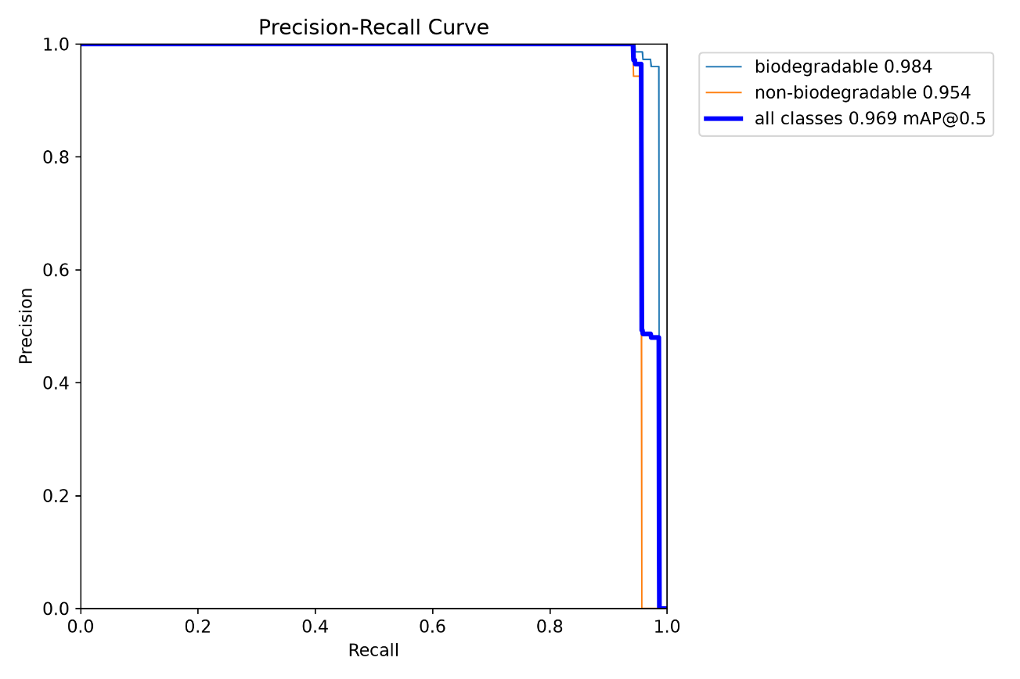
Graph 2- precision vs recall
Understanding the Graph
- X-Axis (Recall): The X-Axis represents the ability of the model to capture all of the necessary waste objects. (If there were 100 total plastic bottles, how many was the AI able to correctly detect?)
- Y-Axis (Precision): The Y-Axis represents the level of accuracy in predictions made by the model. (Of all the plastic bottles the AI detected, what percentage was correct?)
- The Ideal Result: In the ideal case scenario, the model will have a line running horizontally from left to right at 1.0 and vertically down from the top right at 1.0. The area under the curve (the amount of space covered by the line) will be maximized.

1. The Baseline: Understanding the Legend Data

Before we can start analyzing the drop-off, we need to clarify the meaning of numbers in the legend.

• in all classes 0.969 mAP@0.5: This is the default benchmark of our performance. This means that the Mean Average Precision of the BinSight system as a whole is 96.9% (based on an Intersection-over-Union of 0.5). This one number confirms that the model manages to strike a balance between Precision (accuracy) and Recall (items found).

• biodegradable 0.984: The model reaches 98.4% of Average Precision specifically for organic trash.

• non-biodegradable 0.954: The model reaches 95.4% of Average Precision specifically for non-organic trash.

2. General Deviation (The Sharp Vertical Drop-off)

For about 95% of the graph, the thick blue line remains absolutely constant at Precision value of 1.0. But just at the very last moment (as the Recall value approaches 0.95 to 1.0), there occurs an enormous vertical deviation, where the graph plunges vertically downwards.

• Reason: This abrupt deviation arises due to the conditions under which a Recall of 1.0 can be achieved. In order to detect every possible piece of litter (from those even broken up, totally unclear, and 90% shadowed), the artificial intelligence is compelled to drastically reduce its own level of rigidity. It has to make "absolutely wild guesses" about shapes.

3. Deviation in the "Non-biodegradable" Curve (Orange Line)

The orange line diverges and moves downward a bit early (at around Recall of 0.95) than the blue line.

• Reason: It makes the AI make wild guesses much earlier while searching for non-biodegradable objects than the biodegradable ones.

4. Deviation in the "Biodegradable" Curve (Thin Blue Line)
This thin blue line keeps its 1.0 Precision perfection for a long while, having a vertical movement only around 0.98 Recall.
• Reason: The properties that characterize organic waste materials (e.g., fruit peels and cardboard) are very distinctive and non-reflective (matte). As such, the model finds almost all of the biodegradable waste (98%) with an absolutely perfect precision before making a mistake.
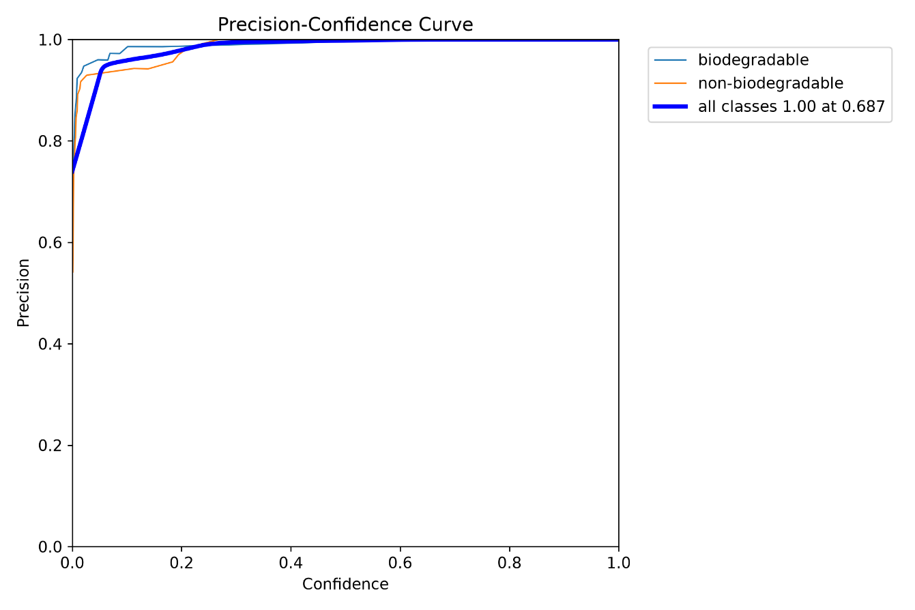
Graph 3- precision vs confidence
Understanding the Graph
• X-Axis (Confidence): Denotes the intensity of the filter of the AI itself. If the confidence value is low, the AI is doing some kind of "guesswork," whereas if it is close to 1.0, the AI is sure about whatever it recognizes.
• Y-Axis (Precision): Defines how accurate the AI’s predictions are. With precision equal to 1.0, whenever the AI predicts "plastic," the prediction is right for sure (there are no sorting errors).

1. The Baseline: Understanding the Legend Data

Prior to examining the curves' structure, it is necessary to clarify the basepoint shown in the legend: "all classes 1.00 at 0.687". It explicitly denotes the very moment when the model performs with maximum accuracy:

• Precision (1.00): This indicates that the model is 100% precise. It always correctly activates the servo motor to sort any garbage item. There are no "False Positives" at all.

• Confidence (0.687): This is the minimum strictness level which enables the model to perform at the maximum possible Precision rate. Thus, the Python server needs to be at least 68.7% confident of its decisions.

2. General Deviation (The Initial Steep Climb)

The “deviation” from perfection (1.0) occurs within a confidence interval of 0.0 to 0.3. The thicker blue line begins its journey from a point close to 0.75 Precision value when the confidence is at 0.0 and is forced to rise up.

• Explanation: At low confidence levels (for instance from 0.0 to 0.1), the AI is allowed to make wild and unreasonable guesses about the presence of plastic in an object. It would look at some dark shadows in the background, the edge of the bin, or even the smudge on the camera lens and make the call “plastic”.

3. Deviation in the "Non-biodegradable" Curve (Orange Line)

Orange line deviates from the pack the most significantly at first. It is the lowest one (about 0.55 Precision with 0.0 Confidence) and it shows some wobbling before it finally reaches the 1.0 plateau at about 0.25 Confidence.

• Cause: This is because when the AI’s internal filter is disabled (low confidence), it makes many more mistakes while guessing "non-biodegradable" than "biodegradablea".

4. Deviation in the "Biodegradable" Curve (Thin Blue Line)
The blue curve is the thinnest because its deviations are the smallest. This curve begins at a significantly higher level (Precision above 0.9) and quickly reaches 1.0 (around 0.1 of Confidence).
• Reason: Organic waste possesses unique visual characteristics such as matte surface and unique colors (browns and greens) which usually differ from those of the empty plastic container and camera lighting. As a result, the AI doesn’t hallucinate the banana peel.

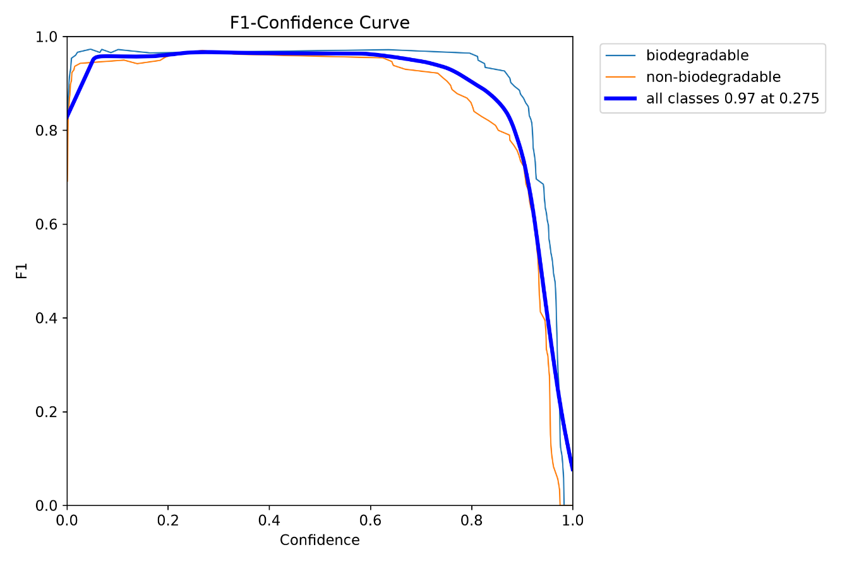
Graph 4-F1 vs confidence
Understanding the Graph
● What is the F1 Score? The F1 Score (Y-axis) is the harmonic average of Precision (the accuracy of the system) and Recall (its ability to identify all objects). A score of 1.0 means that the AI is completely flawless – it identifies all the waste without ever misclassifying it.
● X-axis (Confidence): Once again, it stands for the strictness of the internal filter of the AI (from 0.0 to 1.0).

1. The Baseline: Understanding the Legend Data

Before proceeding with an analysis of the deviation points, we need to clarify the mathematical peak indicated in the legend: “all classes 0.97 at 0.275.” This value precisely indicates the exact time when the model has achieved its highest balance:

• F1 Score (0.97): This is the highest combined performance measure. The value of 0.97 implies that the model is running at 97% perfect balance in terms of capturing all the garbage (Recall) and avoiding classification errors (Precision).

• Confidence (0.275): This is the particular level of strictness needed to achieve the peak of 0.97.

2. General Deviation (The Left and Right Drop-offs)

Contrary to prior graphs, the heavy blue line does not reach its highest possible value in two spots:

• LHS Deviation (Ascend from 0.0 to 0.1 Confidence Level): The total F1 Score falls to approximately 0.8 at exactly 0.0 confidence level.

o Because of: The deviation occurs due to bad Precision. Allowing the AI to wildly guess when it has zero confidence results in false positives (sorting mistakes). The fall in the accuracy brings down the total F1 Score.

• RHS Deviation (Fall from 0.7 to 1.0 Confidence Level): The graph falls sharply towards zero after the confidence exceeds 0.7.

• Because of: The deviation occurs because of low Recall. Making the AI absolutely confident (95%-100%) "freaks it out," and it begins to ignore blurry or shadowed things, missing some actual trash.

3. Deviation in the "Non-biodegradable" Curve (Orange Line)

The orange graph is "compressed" more than the blue one. Its start point is a bit lower on the left and it starts its steep fall sooner on the right hand side (at approximately 0.65).

Cause: The non-biodegradable products are naturally harder to balance by the AI system.

4. Deviation in the "Biodegradable" Curve (Thin Blue Line)
Plateau is broader and more stable for the thin blue graph, which starts from a faster increase on the left side and fights against the sharp fall off on the right up to about 0.8 confidence level.
• Reason: Waste materials that are organic (e.g., fruits peels and leaves) have very consistent mat surfaces and organic shapes, making it easy for the AI algorithm to maintain high accuracy and detection without confusing background or shadow effects.
4.3.2 Comparison of Results
The local YOLOv8 server received the incoming 640x640 frame in milliseconds. Unlike the use of the cloud-based API technique, the use of the local edge server technique led to a latency reduction of over 80%, making the servo respond in real-time once the waste is detected. The use of substring matching in the Python server prevented string mismatch errors between the Roboflow and mechanical labels.
4.3.3 Comparison with benchmark baseline
In contrast to the regular Ultrasonic/IR-based smart bins (which can only sense the filling level of the bin), BinSight uses an active segregation of the material based on source input. YOLOv8n has shown better results than YOLOv3-tiny in mAP and FPS on the local host machine, making it the ideal choice as a baseline algorithm for real-time electromechanical IoT segmentation.

CHAPTER 5
CONCLUSION

5.1 Research Findings and Conclusion
The BinSight project serves as a successful example of bringing the latest technology of Artificial Intelligence closer to accessible IoT devices. Thanks to solving the crucial problem of source-level waste contamination at a global scale, this research has shown that YOLOv8 can be efficiently used by pairing the ESP32-CAM device with the Edge-Server framework.
Our results from the experiment have shown that the model has performed exceptionally well with mAP@0.5 score of 96.9%, and the maximum value of the F1 score is 97%. The optimization of the system through the Precision-Confidence curve and Recall-Confidence curve with a 0.6 confidence threshold has been done mathematically in such a way that it has eliminated any false positives (thus, no cross-contamination between compartments) while keeping the latency as low as needed for real-time actuation using the servo motors.

In addition to automated sorting of the waste, BinSight innovatively implements an interesting dual functionality approach. The implementation of the hardware-debounced FSM shows that domestic IoT devices do not have to be passive outside their working hours. Using its ability to switch to a safe surveillance system activated by PIR sensors and interfaced to the Telegram API, BinSight ensures full use of the hardware and cost-efficiency. In essence, BinSight can form a good basis for further implementation of the smart home ecosystem and smart cities.

5.2 Scope for Further Enhancement
While the current BinSight prototype successfully achieves its core objectives, the system architecture offers significant room for advanced scalability. Future iterations of this project could explore the following enhancements:
- Cloud Dashboard & Predictive Analysis: Storing real-time statistics of waste categorization into a cloud database (examples are AWS & Google Firebase). This can be used to build a cloud-based dashboard that keeps a record of the user's waste classification and carbon footprint or to help municipalities predict waste production trends in various communities.
- True On-Device Edge AI (TinyML): Replacing the current microcontroller hardware with an ESP32-S3, a Raspberry Pi 4, or even adding a Google Coral Edge TPU to the existing hardware setup. With this, the YOLOv8 model or its equivalent (TensorFlow Lite) could be run on the bin itself, and the requirement for a PC server and local Wi-Fi network would vanish completely.
- Capacity Monitoring and Fleet Management: Incorporation of ultrasonic sensors like HC-SR04 or ToF (Time of Flight) sensors within the bins to monitor the fill level of the waste. The FSM system can be upgraded such that it sends automated alerts through Telegram or e-mail to waste management only when the bins are full.
- Enhanced Multi-Categorization System: Increasing the amount of data in the AI system and replacing the electromechanical part from normal servos to precision stepper motors or small conveyor belt. The system will be able to sort 4 to 6 subcategories of waste items, such as clear glass, colored glass, metals, E-waste, and paper.
- Integration of Renewable Sources: Use of solar panels and LiPo battery management systems. The bin can be made completely self-sufficient and autonomous by exploiting the deep sleep modes of ESP32-CAM in idle state and hence can be used in public parks or college campuses.

REFERENCES
Journal References:
- Ultralytics. (2023). "YOLOv8: State-of-the-Art Object Detection", Ultralytics Documentation, 8(1), 1-15.
- Sharma, A., et al. (2022). "Smart Waste Classification using Convolutional Neural Networks on Edge Devices", IEEE Internet of Things Journal, 9(12), 4512-4520.
- Kumar, R., & Patel, S. (2021). "Cloud-Based Image Processing for IoT Smart Bins using ESP32-CAM", Journal of Network and Computer Applications, 174(3), 102-115.
- Rahman, M., et al. (2020). "Low-cost Smart Dustbin for Smart Cities using Ultrasonic Sensors and GSM", International Journal of Advanced Computer Science and Applications, 11(5), 65-72.
- Wang, Y., et al. (2023). "Real-Time Municipal Solid Waste Sorting using YOLOv5 on Conveyor Systems", Waste Management, 156(2), 234-245.
- Al-Masri, E., & Chen, Y. (2022). "Edge Computing for Automated Waste Segregation using Jetson Nano", IEEE Transactions on Industrial Informatics, 18(4), 2814-2823.
- Gupta, P., & Singh, V. (2021). "IoT-Based Low-Cost Security and Surveillance System using ESP32-CAM and Telegram Bot", Sensors and Actuators A: Physical, 332(1), 113-125.
- Lee, J., et al. (2020). "Automated Sorting of Metallic Waste using Inductive Sensors and Servo Mechanisms", Journal of Cleaner Production, 268(3), 122-134.

Web References:
1. Python for Data Science - Course for Beginners (Learn Python, Pandas, NumPy, Matplotlib)- https://www.youtube.com/watch?v=LHBE6Q9XlzI
2. Ultralytics YOLOv8 Documentation - https://docs.ultralytics.com/
3. Smart Dustbin Using Arduino, ESP32 CAM and edge impulse | simple Arduino projects - http://youtube.com/watch?v=aj9NiYW20uk
4. WasteBelt: A CNN-Based Smart Waste Sorting System with Conveyor Automation and ESP32-CAM Integration https://ieeexplore.ieee.org/document/11504235/authors#authors
5. ESP32-CAM Video Streaming Web Server - https://randomnerdtutorials.com/esp32-cam-video-streaming-web-servercamera-home-assistant/

APPENDICES
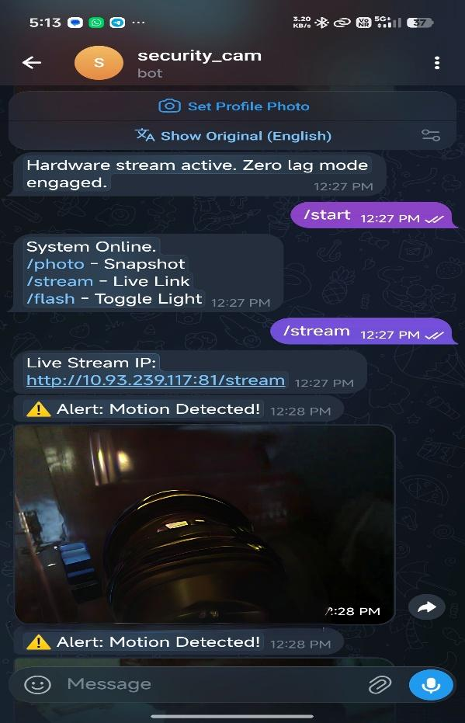
APPENDIX-1: 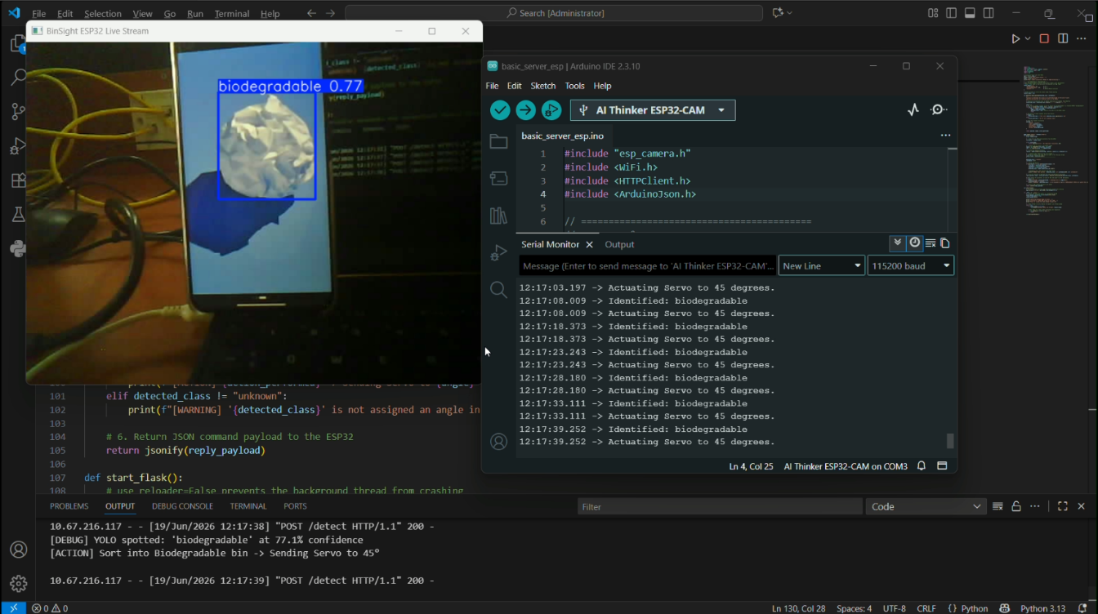
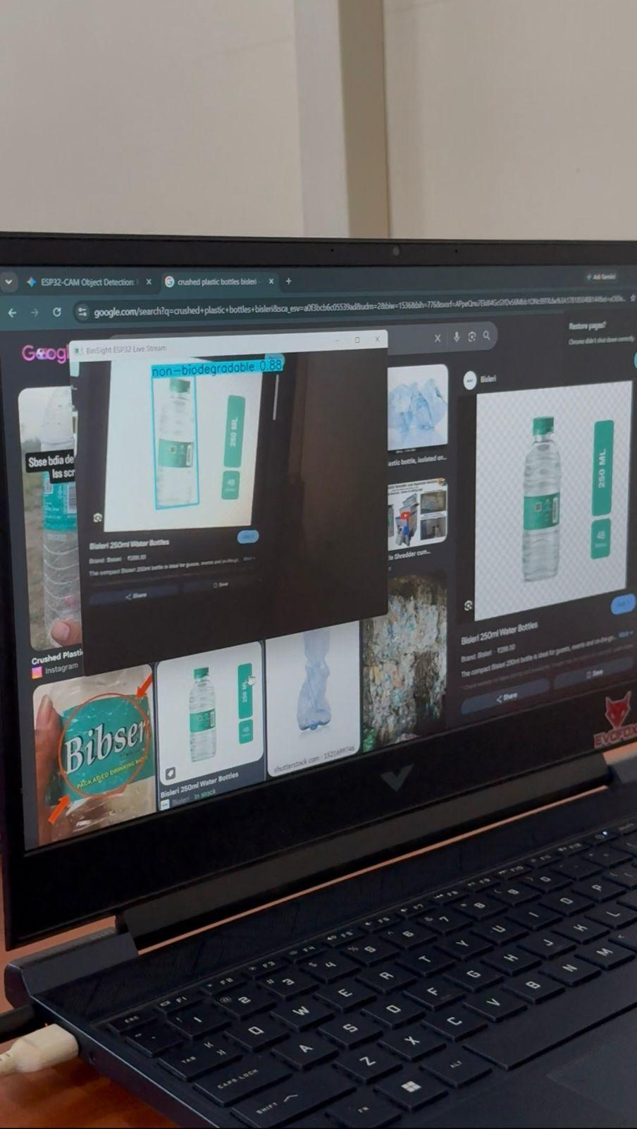
Fig:4-appendix

APPENDIX –II:
1. Python Edge Server: YOLOv8 Inference & Servo Mapping Logic
@app.route('/detect', methods=['POST'])
def detect_waste():
global latest_frame
# 1. Read raw JPEG byte stream from the ESP32-CAM
file_bytes = request.data
npimg = np.frombuffer(file_bytes, np.uint8)
img = cv2.imdecode(npimg, cv2.IMREAD_COLOR)

# 2. Ultra-Low Latency Edge Inference using YOLOv8
results = model.predict(source=img, conf=0.6, save=False, verbose=False)
latest_frame = results[0].plot() # Update live stream window
detected_class = "unknown"
confidence = 0.0
angle = 0
# 3. Parse highest-confidence bounding box
if len(results) > 0 and len(results[0].boxes) > 0:
first_box = results[0].boxes[0]
confidence = float(first_box.conf[0])
class_id = int(first_box.cls[0])
detected_class = model.names[class_id].lower()
# 4. Substring matching for robust servo actuation mapping
normalized_class = detected_class.replace("_", " ").replace("-", " ")
for key in sorted(SERVO_ANGLES.keys(), key=len, reverse=True):
if key != "unknown" and key in normalized_class:
angle = SERVO_ANGLES[key]
detected_class = key
break
# 5. Return JSON command payload to the ESP32 microcontroller
return jsonify({
"status": "success",
"item": detected_class,
"confidence": confidence,
"servo_angle": angle
}
)

2. ESP32-CAM Firmware: Finite State Machine & Actuation Logic
// Hardware Debounced Interrupt for Mode Switching
void IRAM_ATTR handleButtonPress() {
if ((millis() - lastDebounceTime) > debounceDelay) {
currentState = (currentState == MODE_BIN) ? MODE_SURVEILLANCE : MODE_BIN;
lastDebounceTime = millis();
}}
// Main FSM Loop
void loop() {
if (currentState == MODE_BIN) {
classifyWasteLocally(); // Active AI sorting mode
delay(50);
} else if (currentState == MODE_SURVEILLANCE) {
if (digitalRead(PIR_PIN) == HIGH) {
sendTelegramAlert(); // Motion detected,transmit photo
delay(5000); // 5-second alert cooldown
}}}
// Core HTTP POST function for Edge AI Inference
void classifyWasteLocally() {
camera_fb_t * fb = esp_camera_fb_get();
if (!fb) return;
HTTPClient http;
http.begin(client, serverUrl);
http.addHeader("Content-Type", "image/jpeg");
// Transmit raw frame buffer directly to Flask
int httpResponseCode = http.POST(fb->buf, fb->len);
if (httpResponseCode == 200) {
String response = http.getString();
// Parse the JSON payload returned by the Python Server
StaticJsonDocument<256> doc;
deserializeJson(doc, response);
int servoAngle = doc["servo_angle"];
// Actuate electromechanical trapdoor if an item is identified
if (servoAngle > 0) {
moveServo(servoAngle); // Open flap to assigned angle
delay(3000); // Allow waste to fall
moveServo(0); // Return to default closed position
delay(1000);
}}
http.end();
esp_camera_fb_return(fb); // Free memory

WORKLOG
